**ES6-session 1**

**Q1. Given this array: `[3,62,234,7,23,74,23,76,92]`, Using arrow function, create an array of the numbers greater than `70`.**

**Ans:**

let arr2= [3,62,234,7,23,74,23,76,92];

let arrayfun=(newval) => {

return newval > 70 ;

}

let newfun=() =>{

let i=arr2.filter(arrayfun);

console.log(i);

}

console.log(newfun());

Output:

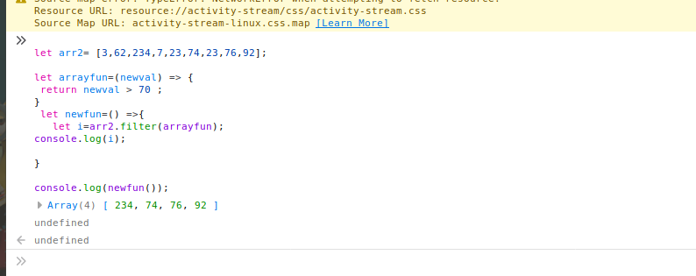

**Q2.**

|  |  |
| --- | --- |
| **<ul>** |  |
|  | **<li data-time="5:17">Flexbox Video</li>** |
|  | **<li data-time="8:22">Flexbox Video</li>** |
|  | **<li data-time="3:34">Redux Video</li>** |
|  | **<li data-time="5:23">Flexbox Video</li>** |
|  | **<li data-time="7:12">Flexbox Video</li>** |
|  | **<li data-time="7:24">Redux Video</li>** |
|  | **<li data-time="6:46">Flexbox Video</li>** |
|  | **<li data-time="4:45">Flexbox Video</li>** |
|  | **<li data-time="4:40">Flexbox Video</li>** |
|  | **<li data-time="7:58">Redux Video</li>** |
|  | **<li data-time="11:51">Flexbox Video</li>** |
|  | **<li data-time="9:13">Flexbox Video</li>** |
|  | **<li data-time="5:50">Flexbox Video</li>** |
|  | **<li data-time="5:52">Redux Video</li>** |
|  | **<li data-time="5:49">Flexbox Video</li>** |
|  | **<li data-time="8:57">Flexbox Video</li>** |
|  | **<li data-time="11:29">Flexbox Video</li>** |
|  | **<li data-time="3:07">Flexbox Video</li>** |
|  | **<li data-time="5:59">Redux Video</li>** |
|  | **<li data-time="3:31">Flexbox Video</li>** |
|  | **</ul>** |

**part-1.Select all the list items on the page and convert to array.**

**Ans.**

var x=document.querySelectorAll("li");

var arr=[];

for(var i=0; i< x.length; i++){

arr.push(x[i].innerText);

}

console.log(arr);

Output:

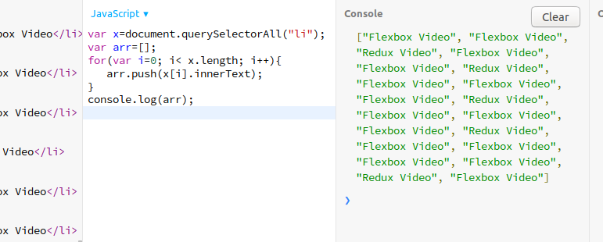

**part-2.Filter for only the elements that contain the word 'flexbox'**

**Ans:**

var x=document.querySelectorAll("li");

var arr=[];

for(var i=0; i< x.length; i++){

arr.push(x[i].innerText);

}

const result=arr.filter(str => str.includes("Flexbox"));

console.log(result);

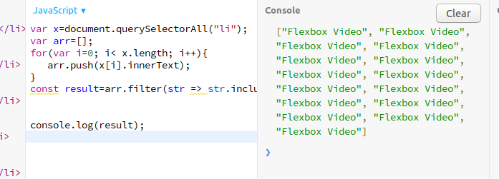

**part-3.map down to a list of time strings**

**Ans:**

var x=document.querySelectorAll("li");

var arr=[];

for(var i=0; i< x.length; i++){

arr.push(x[i].innerText);

}

var temp=Array.prototype.slice.call(x);

var j=temp.map(abc=>{

return abc.dataset.time;});

console.log(j);

Output:

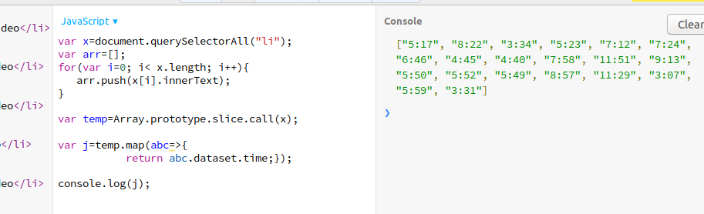

**part-4.map to an array of second**

var x=document.querySelectorAll("li");

var arr=[];

for(var i=0; i< x.length; i++){

arr.push(x[i].innerText);

}

var temp=Array.prototype.slice.call(x);

var j=temp.map(abc=>{

var time= abc.dataset.time;

var convertTosec=time.split(':');

return(convertTosec[0])*60 +parseInt(convertTosec[1]);  
});

console.log(j);

Output:  
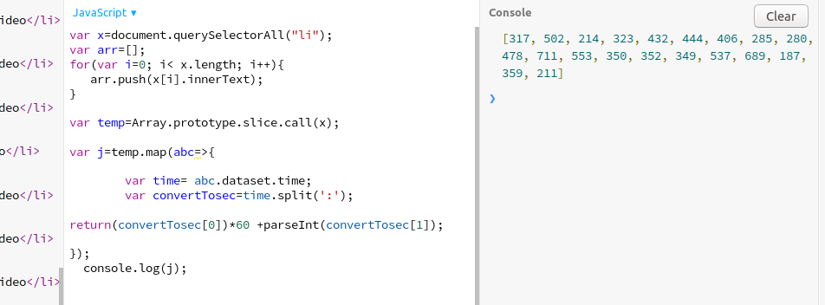

**part-5.reduce to get total using .filter and .map**

**Ans.**

var x=document.querySelectorAll("li");

var arr=[];

for(var i=0; i< x.length; i++){

arr.push(x[i].innerText);

}

function lengthofArray(){

let result=arr.filter(str => str.includes("Flexbox"))

return result.length;

}

var temp=Array.prototype.slice.call(x);

var j=temp.map(abc=>{

var time= abc.dataset.time;

var convertTosec=time.split(':');

return(convertTosec[0])*60 +parseInt(convertTosec[1]);

});

var reduceTime=j.reduce((total,value)=>{

return total+value;

});

var arraylen=lengthofArray();

var obj={Flexbox_Video:arraylen,Timeset:reduceTime}

console.log(obj);

Output:

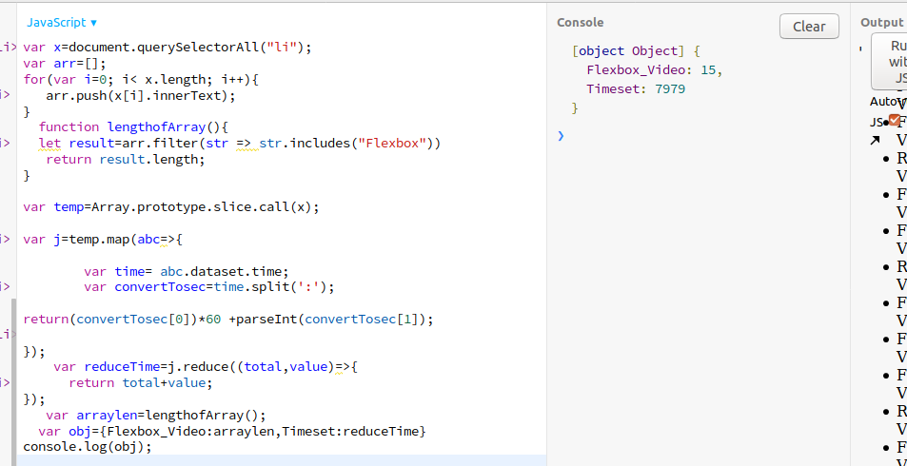

**Q3. Create a markup template using string literal**

**const song = {**

**name: 'Dying to live',**

**artist: 'Tupac',**

**featuring: 'Biggie Smalls'**

**};**

**Result:**

**"<div class="song">**

**<p>**

**Dying to live — Tupac**

**(Featuring Biggie Smalls)**

**</p>**

**</div>**

**“   
Ans:**

const song = {

name: 'Dying to live',

artist: 'Tupac',

featuring: 'Biggie Smalls'

};

console.log(` <div class="song">

<p>

${song.name} - ${song.artist}

(featuring ${song.featuring})

</p>

</div> ` ) ;

**Output:**

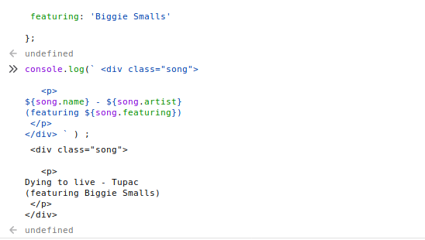

**Q4. Extract all keys inside address object from user object using destructuring ?**

**const user = {**

**firstName: ‘Sahil’,**

**lastName: ‘Dua’,**

**Address: {**

**Line1: ‘address line 1’,**

**Line2: ‘address line 2’,**

**State: ‘Delhi’,**

**Pin: 110085,**

**Country: ‘India’,**

**City: ‘New Delhi’,**

**},**

**phoneNo: 9999999999**

**}**

**Ans:**

const user = {

firstName: 'Sahil',

lastName: 'Dua',

Address: {

Line1: 'address line 1',

Line2: 'address line 2',

State: 'Delhi',

Pin: 110085,

Country: 'India',

City: 'New Delhi',

},

phoneNo: 9999999999

}

-- let {firstName , lastName, Address, phoneNo}=user;

console.log(Address.Line1);

console.log(Address.Line2);

console.log(Address.Pin);

console.log(Address.State);

console.log(Address.Country);

console.log(Address.City);

Output:

